- Press LOW in left side to turn on the radio, LCD will display “SETMOD RESET”, Press A at the panel, radio will show “MAIN UPDATE”, and connect programming cable with radio and computer
- Open file named “Program” in the file I sent t u, 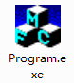, you will see following:
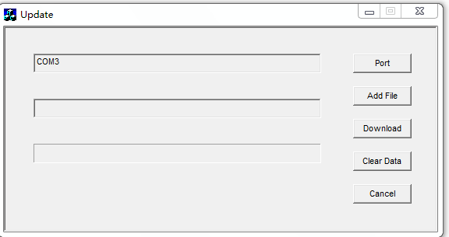

⑴ Select the available comm port
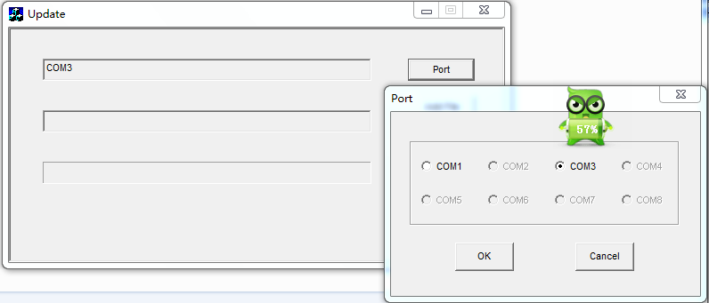

⑵ Click Add File -> choose TH9800DMV1.00.06-P140120-D1401211.ld
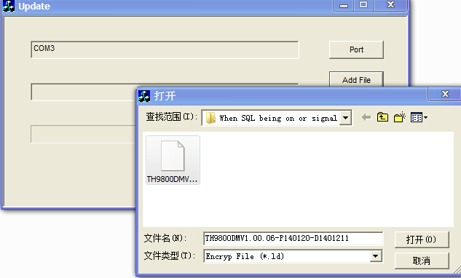
⑶ Click Download
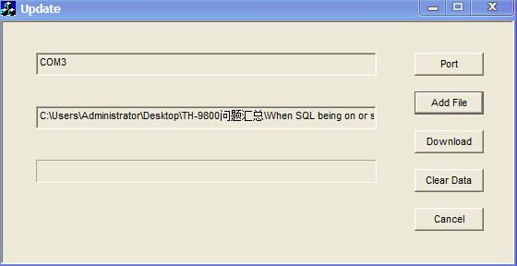

(4) LCD displays 100% and success, now radio cannot automatic turn-off and automatic turn-on self, you have to unplug programming cable and unplug power supply, lastly. Connect power supply again, radio will be power on and everything is okay,

During upgrading, please make sure that power supply is always on, if radio is power off or power supply stops, the upgrading will stop and this radio cannot use again

